Our Granhub grandparents' social community typically can offer several compelling selling points to attract members:

1. **Connection with Family:** It provides a platform for grandparents to stay connected with their children and grandchildren, especially if they live far away. This can include sharing photos, videos, and updates in a private and secure environment.



1. **Community Support:** It offers a community of peers who are also grandparents, allowing them to share experiences, advice, and support each other through the joys and challenges of grandparenting.
2. **Resource Sharing:** Members can exchange tips on activities, recipes, health advice, and other relevant topics related to grandparenting.
3. **Events and Activities:** The platform may organize virtual events, workshops, or webinars tailored for grandparents, creating opportunities for learning and engagement.
4. **Privacy and Security:** Emphasis is typically placed on maintaining a safe and private space for sharing family-related content, often with features like restricted access and secure data storage.
5. **User-Friendly Interface:** The platform is designed to be easy to use, even for older adults who may not be as tech-savvy, with intuitive navigation and clear instructions.

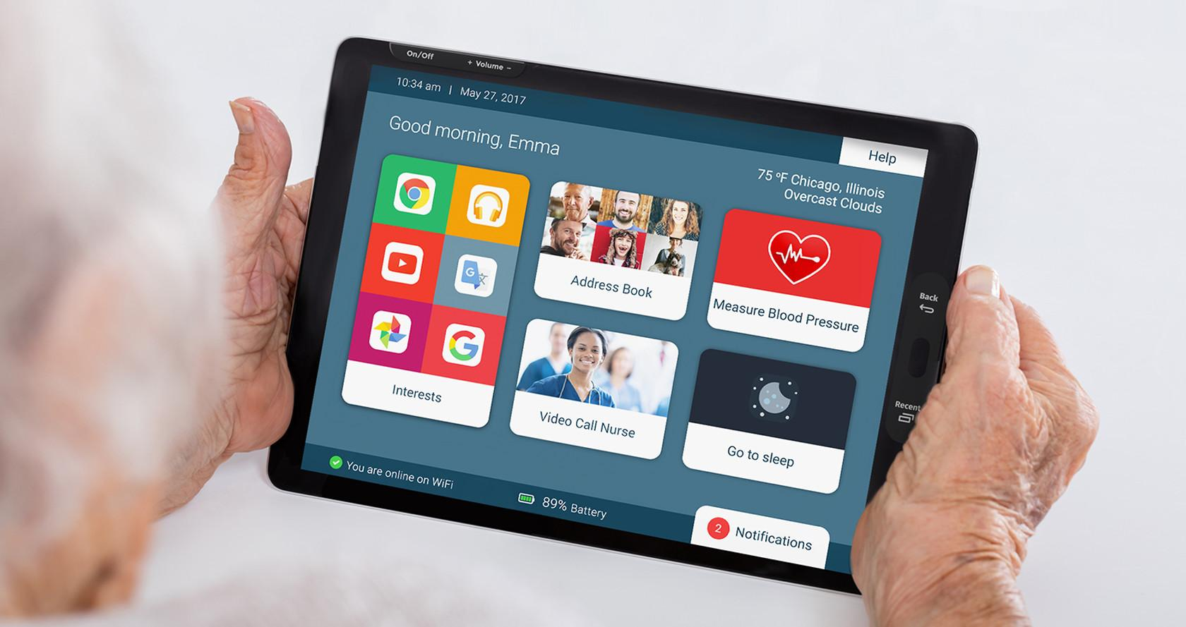

1. **Memories and Legacy:** It serves as a digital archive where grandparents can chronicle their family history, preserving memories for future generations.
2. **Exclusive Deals and Discounts:** Some platforms partner with businesses to offer special discounts or deals on products and services relevant to grandparents and their families.



1. **Customization and Personalization:** Members can personalize their profiles and interactions to reflect their unique family dynamics and preferences.

Overall, the selling points of an online grandparents' social community revolve around fostering connections, providing support, and enhancing the grandparenting experience in a safe and enjoyable digital environment.